**Pivi: An eclipse Pug-In for Visual Parallel Programming**

**Sponsor: Javier Gonzalez**

Team Members

Panchavati Ganesh, Sri Kiran

Kara, Pujitha

Kogaleru, Nithya

Peddabuttaiahgari ,Giridhar

Shendware, Snehal

**Summary**

The Pivi aims at providing an easier and interactive way to create a visual model of a problem. It is primarily intended for use by students. By theoretically studying the concepts, students may find it difficult to understand them and to implement them in a program. Another major issue is that a lot of time and effort is needed to program a problem using legacy textural programming languages, especially for students who are in a learning phase. Concepts like parallel programming, concurrent programming and multicore programming are complex and require deep understanding to implement them. This eclipse plug in Pivi addresses to solve all these problems.

Solving the above-mentioned problems is important as it is easy to visualize a solution to a problem. For beginners, it is simple and facilitates to create a visual model of a problem. Support for visual programming helps to reduce the time that students need to invest in programming a solution to a problem using textural programming languages and facilitates for a rapid development. Since the tool validates the linking of icons that represent programmable constructs and generates the code automatically, the chances of syntax errors in the code is highly reduced. Concepts like parallel programming can solve many complex problems. By understanding such concepts deeply, students can increase their problem-solving skills.

This Eclipse Plug-In is focused on facilitating teaching/learning techniques and implications of parallel, concurrent and multicore programming. The developed software is an Eclipse plugin that allows users to visually program in Java. The plugin presents a palette of icons that can be used to create a program visually. Each icon in the palette represents different constructs of a programming language. The plugin also presents a canvas on which user can place the necessary icons from the palette to create a program. The plugin should allow users to connect the icons present on the canvas by validating the connections. The user will be able to modify the parameters provided for each icon. Concurrent programming features are provided by the plugin. This includes creation of threads, execution of instructions in multiple threads, access to the memory among threads. The plugin also validates if the graph of icons and connections created on the canvas is a valid program. For a valid program created visually on graph, the plugin generates the code in Java programming language which can be understood by the user in an effective way.

**Requirements and Schedule**

|  |  |  |  |  |
| --- | --- | --- | --- | --- |
| **#** | **Functional Requirements** | **Tasks** | **Due Date** | **Status** |
| 1 | User should be able to access Pivi Plugin in Eclipse Environment. | * Select Pivi plugin perspective option in Eclipse Toolbar * The final deliverable is a plugin that can be installed in Eclipse | 02/01/2017 | Completed |
| 2 | User should be able to program using visual elements in Pivi by creating a Pivi file. | * Create Pivi palette with UI programmable nodes and connections. * Create a graph area where the user can drag the elements in palette and create a diagram out of it. * Enable a property view to edit the properties of the nodes. | 02/22/2017 | Completed |
| 3 | User should be able to create diagram using the nodes and connections. | * Nodes should be allowed to drag into the canvas * Nodes should be able to be connected using the connections * Connections between the nodes need to be validated. | 03/08/2017 | Completed |
| 4 | Required nodes need to be present in the palette to create programming constructs visually | * Nodes should be present to enter instructions * Nodes should be present to create if statements and while statements * Nodes need to be present to create methods | 03/22/2017 | Completed |
| 5 | User should be able view/edit generated code after visual programming. | * Provide “Generate” option for code generation in JAVA * Generate code in a format understandable to user from visual UI elements and underlying Model | 04/05/2017 | Completed |
| 6 | Visual representation of the icons need to be consistent | * All the nodes should be of same size * Nodes should have image in it that describes the node * Nodes should have fragments that can be used to connect the nodes | 04/19/2017 | Completed |
| 7 | Popups should be provided to edit properties. | * On double click of each node a popup should be provided to edit properties. | 04/19/2017 | Completed |

**Software Design**

1. **Class Diagram:**

**Asu.ser.capstone.pivi.parser package**

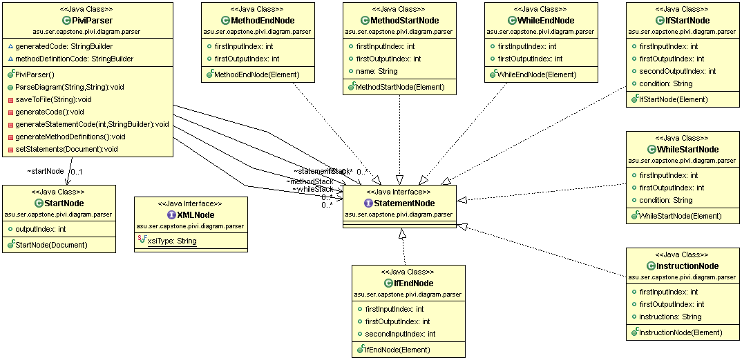

**Asu.ser.capstone.pivi package**

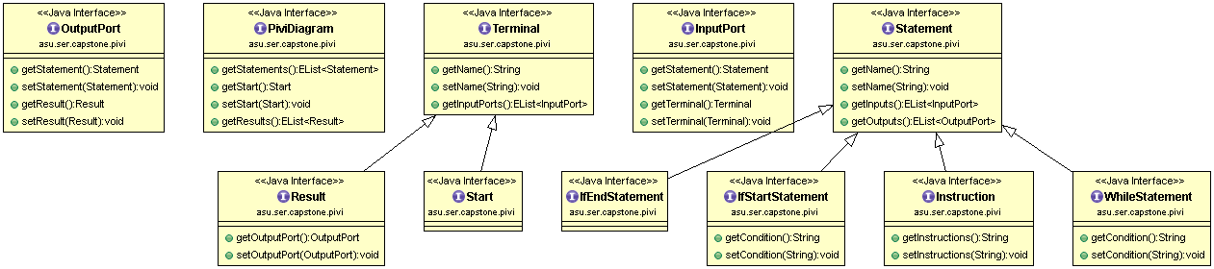

**Asu.ser.capstone.pivi.diagram.edit.parts.custom package**  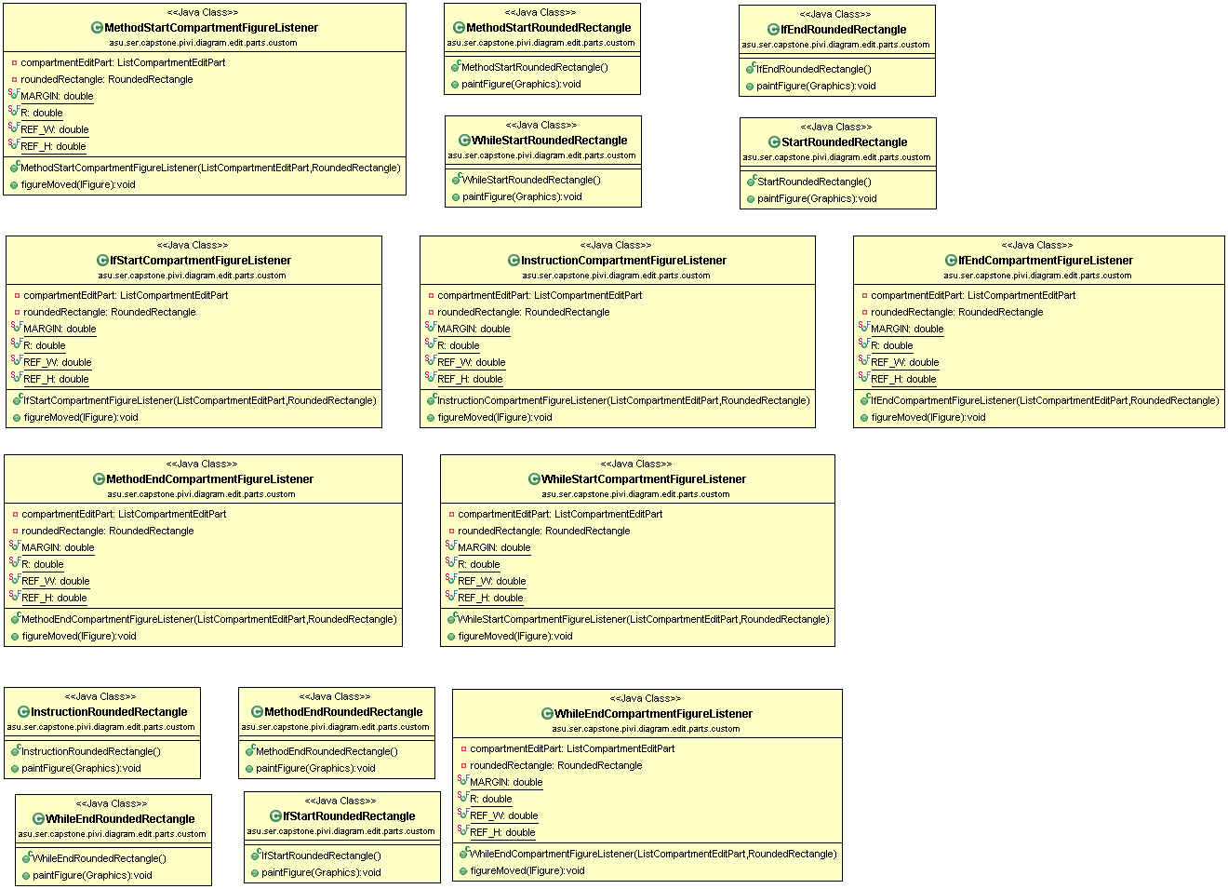

**Asu.ser.capstone.pivi.diagram.part.custom package**

